# **Operational Concept Description (OCD)**

**Fooder**

**QWERTY**

**Jake Motta - Co-Lead Programmer, Graphics Designer**

**Alex Le - Project Manager, Co-Lead Programmer**

**Brendan Kao - Co-Lead Programmer, Tester**

**Jason Springer - Co-Lead Programmer, Quality Assurance**

# **Version History**

|  |  |  |  |  |
| --- | --- | --- | --- | --- |
| Date | Author | Version | Changes made | Rationale |
| 3/08/17 | Q’s | 1.0 | · Original template v1.0 | · Initial draft |
| 3/08/17 | BK | 1.1 | · Added everything but diagrams | · Added all the written parts  · Added all the tables |
| 3/12/17 | BK | 1.2 | · Added 2.3 and 3.3 | · Added some tables |
| 3/14/17 | BK | 1.3 | · Added the rest | · Finalized the tables |
|  |  |  |  |  |
|  |  |  |  |  |
|  |  |  |  |  |
|  |  |  |  |  |

# **Table of Contents**

Operational Concept Description (OCD)......................................................................................

Version History.............................................................................................................................. 2

Table of Contents......................................................................................................................... 2

Table of Tables............................................................................................................................. 3

Table of Figures............................................................................................................................ 3

1. Introduction.............................................................................................................................. 3

1.1 Purpose of the OCD......................................................................................................... 3

1.2 Status of the OCD............................................................................................................ 4

2. Shared Vision................................................................................................................... 4

2.1 Benefits Chain.................................................................................................................. 5

2.2 System Capability Description.......................................................................................... 5

2.3 System Boundary and Environment................................................................................. 6

3. System Transformation..................................................................................................... 6

3.1 Information on Current System......................................................................................... 6

3.2 System Objectives, Constraints and Priorities.................................................................. 7

3.3 Proposed New Operational Concept.............................................................................. 10

3.4 Organizational and Operational Implications.................................................................. 11

# **Table of Tables**

Table 1: The Program Model 4

Table 2: Capability Goals 7

Table 3: Level of Service Goals 8

Table 4: Relation to Current System. 9

# **Table of Figures**

Figure 1: Benefits Chain Diagram for Fooder developers. 5

Figure 2: System Boundary and Environment Diagram for Fooder. 6

Figure 3: Business Workflow for Fooder. 7

Figure 4: Element Relationship Diagram for Fooder. 10

Figure 5: Business Workflow for Fooder. 11

### **1.** **Introduction**

#### **1.1** **Purpose of the OCD**

This document provides in detail, the shared visions and goals of the stakeholders of “Fooder” for people that have smart phones. The stakeholders of the project are Ramin Moazeni, as the stakeholder, smartphone users, as users, and Team Qwerty, as the maintainer.

#### 

#### 

#### 

#### 

#### **1.2** **Status of the OCD**

Status of OCD is currently in its initial developmental stages as version 1.0. Our current scope of Fooder is to create a working prototype that will allow users to swipe left or right to either decline the restaurant or add it to user’s restaurant bucket list. Users will also be able to immediately go to the restaurant using the Map API built into android devices. As we continue on through our developmental phases and as challenges emerge, we will re-evaluate to accommodate our challenges while maintaining focus on finalizing our application.

### **2.** **Shared Vision**

Table 1: The Program Model

|  |  |  |  |
| --- | --- | --- | --- |
| **Assumptions**  People are no longer satisfied with Yelp’s design  Short on time and need quick suggestions | | | |
| **Stakeholders** | **Initiatives** | **Value Propositions** | **Beneficiaries** |
| * QWERTY (Developers) * Professor Moazeni * App users * Small businesses | * Learn Android Studio * Develop new system * Develop tutorial for easy learning * Promote users to join Fooder | * Gain knowledge on mobile development * Creating an easy to use application that can join the Google Play store * Quick to use with one hand * Create a fair way to find restaurants | * Users of “Fooder” * Class of CS161 * QWERTY * Businesses |

#### **2.1** **Benefits Chain**

Figure 1: Benefits Chain Model for Fooder developers

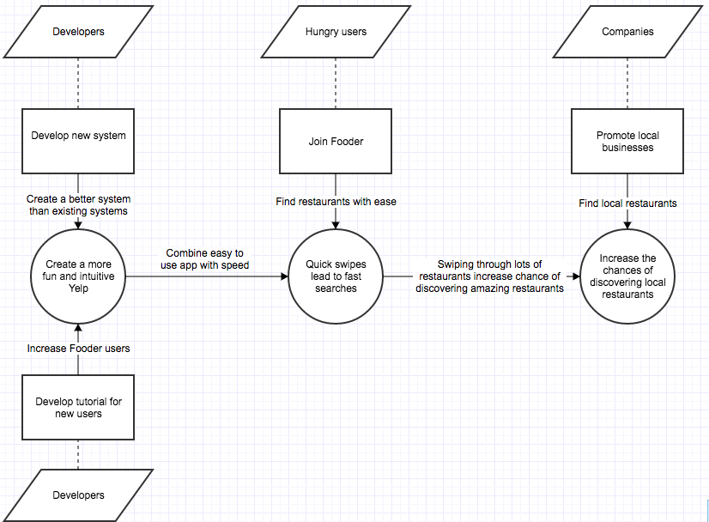

#### **2.2** **System Capability Description**

OUR PROJECT IS Fooder

FOR *smartphone users*

WHO *can’t decide on a restaurant*

Fooder IS AN *android applicatio*n

THAT *suggests restaurants nearby in a simple manner*

UNLIKE *Yelp*

OUR WEB SERVICE *is quick and easy to use*

#### 

#### 

#### **2.3** **System Boundary and Environment**

Figure 2: System Boundary and Environment Diagram for Fooder

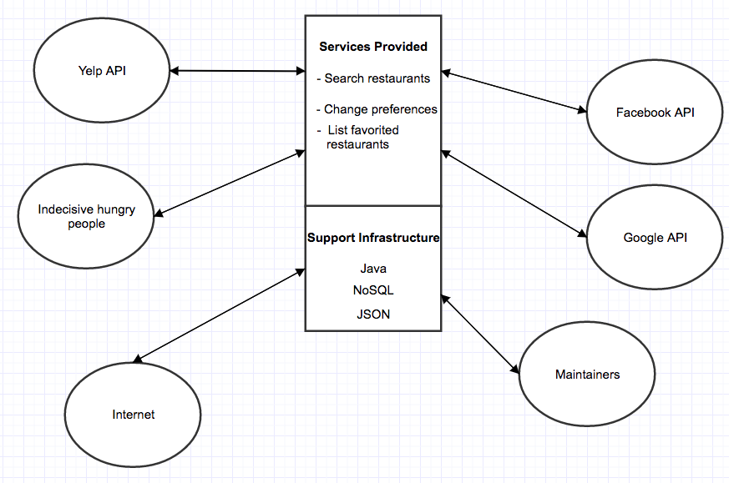

### **3.** **System Transformation**

#### **3.1** **Information on Current System**

##### **3.1.1** **Infrastructure**

Android Studio

Laptops

Google Firebase

Google Maps

Yelp API

##### 

##### **3.1.2** **Artifacts**

Class Diagram

*Provides an organized diagram that describes the structure of our app*

Use Case Diagram

*Provides a list of actions that help model the functionality of our app using actors and use cases*

Benefit Chain Diagram

*Provides a list of win conditions to achieve during the project*

##### **3.1.3** **Current Business Workflow**

Figure 3: Business Workflow for Fooder

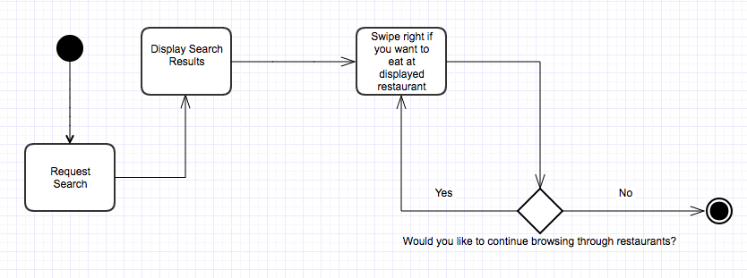

#### **3.2** **System Objectives, Constraints and Priorities**

##### **3.2.1** **Capability Goals**

Table 2: Capability Goals

|  |  |
| --- | --- |
| **Capability Goals** | **Priority Level** |
| OC-1: The application is capable of displaying restaurants near the user | Must have |
| OC-2: The application is fast. It displays images in a timely manner. | High |
| OC-3: The application is able to store favorite restaurants | Medium |

##### **3.2.2** **Level of Service Goals**

Table 3: Level of Service Goals

##### 

|  |  |  |
| --- | --- | --- |
| **Level of Service Goals** | **Priority Level** | **Referred WinWin Agreements** |
| **LOS-1** Users can find what restaurant they want in a matter of minutes | Very High |  |
| **LOS-2** Users will be shown places they are likely to visit | Medium |  |

##### 

##### **3.2.3** **Organizational Goals**

**OG-1:** Improve customer satisfaction

**OG-2:** Improve speed via faster querying

**OG-3:** Learn how to manage databases

##### **3.2.4** **Constraints**

**CO-1**: **Android Operating System:** Application must be able to run on Android platform

**CO-2: Zero Monetary Budget:** All API’s and features used for the development of the application must be free

**CO-3:** **Java as a Development Language:** Java must be used for android

##### 

##### 

##### 

##### 

##### 

##### 

##### **3.2.5** **Relation to Current System**

Table 4: Relation to Current System

|  |  |  |
| --- | --- | --- |
| **Capabilities** | **Current System** | **New System** |
| Roles and Responsibilities | N/A | N/A |
| User Interactions | User searches for random restaurant around the area | System will learn preferences |
| Infrastructure | No infrastructure | Have our own API and database |
| Stakeholder Essentials and Amenities | New restaurants could be missed | Users can find soft opening restaurants |
| Future Capabilities | N/A | Will be able to view other people’s favorites |

#### 

#### 

#### 

#### 

#### 

#### 

#### 

#### 

#### 

#### 

#### **3.3** **Proposed New Operational Concept**

##### **3.3.1** **Element Relationship Diagram**

Figure 4: Element Relationship Diagram for Fooder

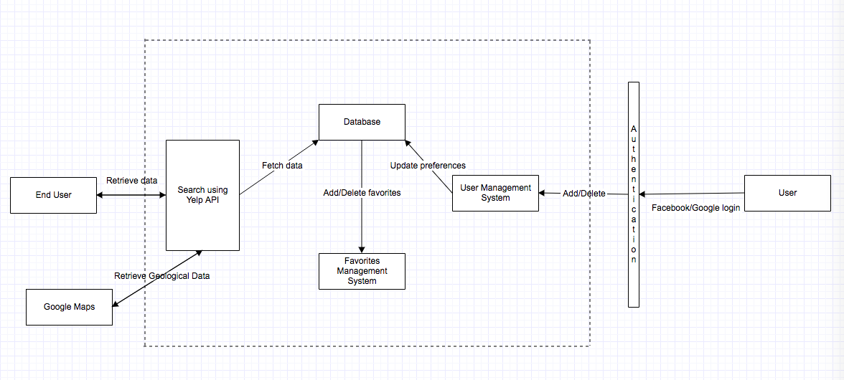

##### 

##### 

##### 

##### 

##### 

##### 

##### 

##### 

##### 

##### 

##### 

##### 

##### 

##### 

##### **3.3.2** **Business Workflows**

Figure 5: Business Workflow for Fooder

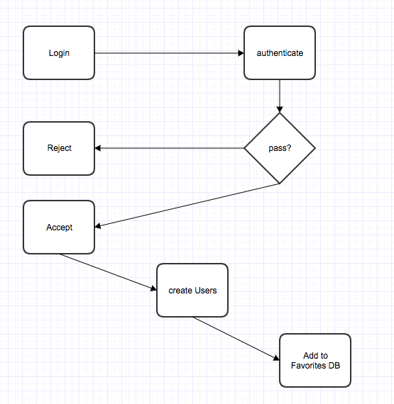

#### **3.4** **Organizational and Operational Implications**

##### **3.4.1** **Organizational Transformations**

Nothing at the moment

##### **3.4.2** **Operational Transformations**

N/A